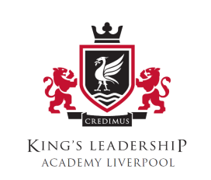

Most Recent End of KS4 Results & Pupil Progress 2017

Progress 8 Score | -0.13
Attainment 8 Score | 35.1
% of students who achieved grade 5/C or above in GCSE English and Maths | 20%
% of students entering the English Baccalaureate | 17%
% of students who achieving the English Baccalaureate at Grade 5/C or Above | 4%
% of students staying in Education, Employment and Training | 90.5%

