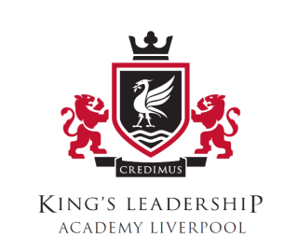

KS3 Curriculum Plan
Subjects Studied by Year Group
Subject | Yr7 | Yr8
Aspire | √ | √
Art | √ | √
Drama | √ | √
DT | √ | √
English | √ | √
Geography | √ | √
History | √ | √
IT | √ | √
Maths | √ | √
Music | √ | √
PE | √ | √
Science | √ | √
Spanish | √ | √

