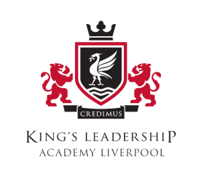

Senior Leadership Team

Chief Executive Officer : Sir Iain Hall
Principal : Mr Mark O’Hagan
Chair of Governors: Mrs Robina Crowe
Vice Principal: Mr Scott Cordon
Assistant Principal/DSL/SENCo: Miss Rebecca McCarthy
Assistant Principal: Mr David Crosby
Assistant Principal: Mrs Kate Eccleston
Business Manager: Mr David Cain

